OBJECT ORIENTED PROGRAMMING

[CT-260]



NAME: ABDUL RAHEEM SHEIKH

ROLL NO: CT-25192

DEPARTMENT: BCIT

BATCH: 2025

YEAR & SECTION: FSCS-D

LAB: 09

CODES
QUESTION 01
#include <iostream>
using namespace std;

// Abstract Class
class ArrayMultiplier {
public:
virtual void calculate() = 0;
};

// 1D Array Multiplication
class ArrayMultiplier1D : public ArrayMultiplier {
int arr[5];

public:
ArrayMultiplier1D() {
cout << "Enter 5 elements for 1D array:\n";
for (int i = 0; i < 5; i++) {
cin >> arr[i];
}
}

void calculate() {
int product = 1;

for (int i = 0; i < 5; i++) {
product *= arr[i];
}

cout << "1D Array Multiplication = " << product << endl;
}
};

// 2D Array Multiplication
class ArrayMultiplier2D : public ArrayMultiplier {
int arr[2][2];

public:
ArrayMultiplier2D() {
cout << "Enter 4 elements for 2D array:\n";

for (int i = 0; i < 2; i++) {
for (int j = 0; j < 2; j++) {
cin >> arr[i][j];
}
}
}

void calculate() {
int product = 1;

for (int i = 0; i < 2; i++) {
for (int j = 0; j < 2; j++) {
product *= arr[i][j];
}
}

cout << "2D Array Multiplication = " << product << endl;
}
};

int main() {

ArrayMultiplier *ptr;

ArrayMultiplier1D obj1;
ptr = &obj1;
ptr->calculate();

ArrayMultiplier2D obj2;
ptr = &obj2;
ptr->calculate();

return 0;
}

OUTPUT:
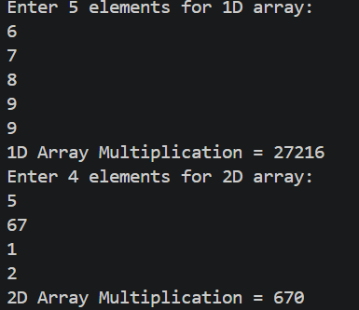

QUESTION 02
#include <iostream>
using namespace std;

// Abstract Class
class Store {
protected:
float total_bill;

public:
Store(float bill) {
total_bill = bill;
}

virtual void calculateBill() = 0;
};

// Imtiaz Store
class ImtiazStore : public Store {
public:
ImtiazStore(float bill) : Store(bill) {}

void calculateBill() {
float finalBill = total_bill - (total_bill * 0.07);

cout << "Imtiaz Store Final Bill = " << finalBill << endl;
}
};

// Bin Hashim Store
class BinHashimStore : public Store {
public:
BinHashimStore(float bill) : Store(bill) {}

void calculateBill() {
float finalBill = total_bill - (total_bill * 0.05);

cout << "Bin Hashim Store Final Bill = " << finalBill << endl;
}
};

int main() {

float bill;

cout << "Enter Total Bill: ";
cin >> bill;

Store *ptr;

ImtiazStore i(bill);
ptr = &i;
ptr->calculateBill();

BinHashimStore b(bill);
ptr = &b;
ptr->calculateBill();

return 0;
}

OUTPUT:

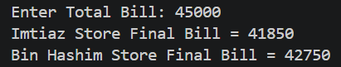

QUESTION 03
#include <iostream>
#include <string>
using namespace std;

// Abstract Base Class
class Vehicle {
protected:
int carId;
string brand;
string model;

public:
Vehicle(int id, string b, string m) {
carId = id;
brand = b;
model = m;
}

virtual bool isAvailable() = 0;
virtual void rent() = 0;
virtual void returnVehicle() = 0;

virtual void display() {
cout << "Car ID: " << carId << endl;
cout << "Brand: " << brand << endl;
cout << "Model: " << model << endl;
}

virtual ~Vehicle() {}
};

// Derived Class
class Car : public Vehicle {
bool available;

public:
Car(int id, string b, string m)
: Vehicle(id, b, m) {
available = true;
}

bool isAvailable() {
return available;
}

void rent() {
if (available) {
available = false;
cout << model << " rented successfully.\n";
}
else {
cout << model << " is already rented.\n";
}
}

void returnVehicle() {
available = true;
cout << model << " returned successfully.\n";
}
};

// Rental System
class RentalSystem {
public:
void rentVehicle(Vehicle *v) {

if (v->isAvailable())
v->rent();
else
cout << "Vehicle not available.\n";
}

void returnVehicle(Vehicle *v) {
v->returnVehicle();
}
};

// Customer Class
class Customer {
string name;

public:
Customer(string n) {
name = n;
}

void rentVehicle(RentalSystem &system, Vehicle *v) {
cout << name << " wants to rent vehicle.\n";
system.rentVehicle(v);
}

void returnVehicle(RentalSystem &system, Vehicle *v) {
cout << name << " returned vehicle.\n";
system.returnVehicle(v);
}
};

int main() {

Vehicle *vehicles[2];

vehicles[0] = new Car(1, "Toyota", "Corolla");
vehicles[1] = new Car(2, "Honda", "Civic");

RentalSystem system;

Customer c1("Ali");

c1.rentVehicle(system, vehicles[0]);

cout << endl;

c1.returnVehicle(system, vehicles[0]);

// Free memory
for (int i = 0; i < 2; i++) {
delete vehicles[i];
}

return 0;
}

OUTPUT:

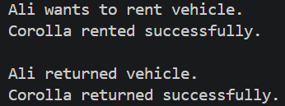

QUESTION 04
#include <iostream>
#include <string>
using namespace std;

// Abstract Class
class EncryptionTechnique {
public:
virtual void encrypt(string message) = 0;
};

// Technique 1
class EncryptionTechnique1 : public EncryptionTechnique {
public:
void encrypt(string message) {

string result = "";

for (int i = 0; i < message.length(); i++) {
result += to_string((int)message[i]);
}

cout << "Technique 1 Encryption: " << result << endl;
}
};

// Technique 2
class EncryptionTechnique2 : public EncryptionTechnique {
public:
void encrypt(string message) {

string result = "";

for (int i = 0; i < message.length(); i++) {
result += to_string((int)message[i] + 2);
}

cout << "Technique 2 Encryption: " << result << endl;
}
};

int main() {

string message;

cout << "Enter Message: ";
getline(cin, message);

EncryptionTechnique *ptr;

EncryptionTechnique1 e1;
ptr = &e1;
ptr->encrypt(message);

EncryptionTechnique2 e2;
ptr = &e2;
ptr->encrypt(message);

return 0;
}

OUTPUT:

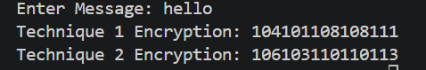

QUESTION 05

#include <iostream>
#include <string>
using namespace std;

// Abstract Class
class DecryptionTechnique {
public:
virtual void decrypt(string code) = 0;
};

// Technique 1 Decryption
class DecryptionTechnique1 : public DecryptionTechnique {
public:
void decrypt(string code) {

cout << "Technique 1 Decryption: ";

for (int i = 0; i < code.length(); i += 2) {

string temp = code.substr(i, 2);

char ch = stoi(temp);

cout << ch;
}

cout << endl;
}
};

// Technique 2 Decryption
class DecryptionTechnique2 : public DecryptionTechnique {
public:
void decrypt(string code) {

cout << "Technique 2 Decryption: ";

for (int i = 0; i < code.length(); i += 2) {

string temp = code.substr(i, 2);

char ch = stoi(temp) - 2;

cout << ch;
}

cout << endl;
}
};

int main() {

string code1, code2;

cout << "Enter Technique 1 Encrypted Code: ";
cin >> code1;

cout << "Enter Technique 2 Encrypted Code: ";
cin >> code2;

DecryptionTechnique *ptr;

DecryptionTechnique1 d1;
ptr = &d1;
ptr->decrypt(code1);

DecryptionTechnique2 d2;
ptr = &d2;
ptr->decrypt(code2);

return 0;
}

OUTPUT:

